Q1:

Symbolic: it works for simple functions and is pretty accurate, it is as accurate as f. However, it is not efficient for functions that involve complex simulation or calculation to be evaluated.

finite differences: only works if f can be evaluated with infinite precision/accuracy. Too high or too low h will yield bad derivative estimation. This is not the most efficient method.

automatic differentiation: it is fast and efficient with modern implementation (fastest in these three methods), and it is very accurate.

Q2:

When initial is x1 = -0.4336 and x2 = 0.3426

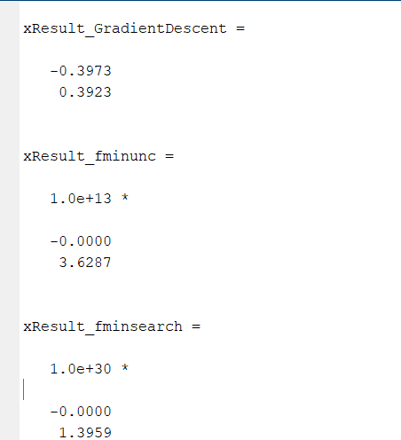

When initial is x1 = 3.5784 and x2 = 2.7694

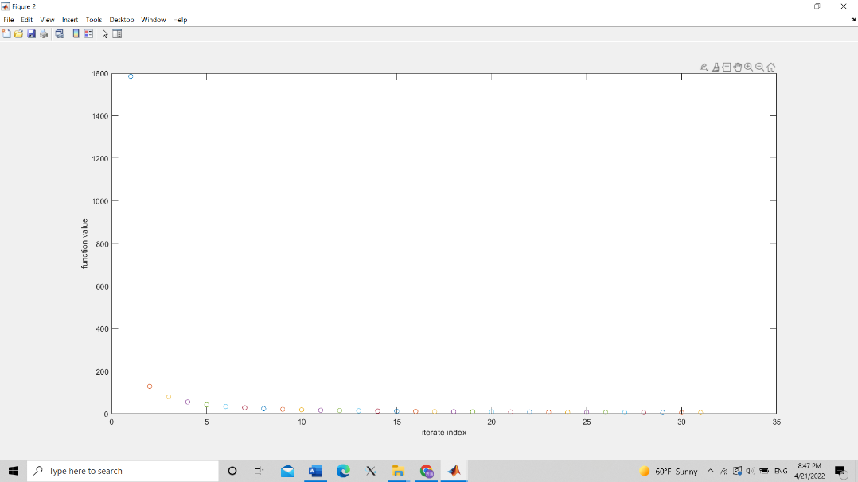

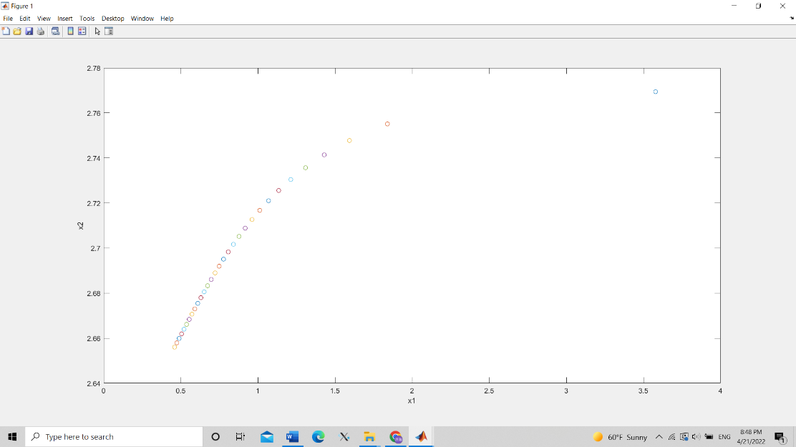

Q4:

Q5:

In this problem, I used a large number of epochs which is 20. First, run with default L2Regularization which is 1\*10^-4.

a) the program runs pretty slow which costs 3 mins and 59 seconds. The accuracy is 90.52%.

b) After adding another convolution2DLayer, bathchnormalization, and reLULayer, the program runs even slower which costs 6 mins and 20 seconds. The accuracy increases a litter bit which becomes 91.11%.

c) I add the trio of layers: fully connected + reLu + batchnorm and increase epochs to 30. The running time keeps increasing to 9 min 17 sec. The accuracy increases a lot and becomes 93.11%.

Q6:

a)

The accuracy is 62%

b)

The accuracy is 66%

c)

To increase the accuracy, I choose to increase the epochs from 20 to 30. The accuracy only increase a lit bit but running for a much longer time.

The accuracy is 67%

Q8:

1. My computer has a GPU

b) My computer will be training on single GPU as default. With double convolution2DLayer, bathchnormalization, and reLULayer, and trio of layers: fully connected + reLu + batchnorm, the running time is 9 min 17 sec and the accuracy is 93.11%.

Then I force my computer to run with cpu. In the same condition, CPU is much slower than GPU. The running time is 103 min 26 sec and the accuracy is 92.94%.

Q9:

This example shows how to fit a regression model using convolutional neural networks to predict the angles of rotation of handwritten digits. The example constructs a convolutional neural network architecture, trains a network, and uses the trained network to predict angles of rotated handwritten digits.   
